**CCT College Dublin**

**Assessment Cover Page**

*To be provided separately as a word doc for students to include with every submission*

|  |  |
| --- | --- |
| **Module Title:** | *Data Preparation / Machine Learning* |
| **Assessment Title:** | *Integrated CA2* |
| **Lecturer Name:** | *David McQuaid / Muhammad Iqbal* |
| **Student Full Name:** | Giovana Froelich |
| **Student Number:** | 2024091 |
| **Assessment Due Date:** | *18th April 2024* |
| **Date of Submission:** | *24th May 2024* |

**Declaration**

|  |
| --- |
| By submitting this assessment, I confirm that I have read the CCT policy on Academic Misconduct and understand the implications of submitting work that is not my own or does not appropriately reference material taken from a third party or other source. I declare it to be my own work and that all material from third parties has been appropriately referenced. I further confirm that this work has not previously been submitted for assessment by myself or someone else in CCT College Dublin or any other higher education institution. |

Summary

1. Introduction 3

2. Data Preparation 4

2.1. Characterizations of the Dataset 4

2.2. Missing Values 5

2.3. Rename Columns 5

2.4. Outliers 6

2.5. EDA (Exploratory Data Analysis) 6

3. Encoding 10

4. Scaling 12

5. Dimensional Reduction: PCA vs LDA 14

5.1. Principal Component Analysis (PCA) 14

5.2. LDA (Linear Discriminant Analysis) 15

5.3. Accuracy PCA and LDA 16

6. Data Preparation conclusion 18

7. Machine Learning 19

7.1. Split, train and test 19

7.2. Feature Importances 20

7.3. Hyperparameter 21

7.4. Training and Testing the Models 22

7.5. Random Forest Classifier 24

7.6. SVC (Support Vector Classifier) 25

8. Machine Learning Conclusion 26

9. References 27

1. **Introduction**

When we talk about health, we can see a scenario of rapid evolution and growth in recent years, and data analysis plays an extremely important role in this expansion, as it provides valuable insights that help professionals make decisions, as they are based on past evidence that can be used to identify patterns among them. Following these results, advanced analysis and machine learning techniques are used to identify risk factors and predict future diseases.

This case study includes data from a company in the healthcare sector, such as patient demographics, health metrics and treatment details. An analysis will be made of the data presented, the insights, the questions, the treatment of the data, the search for some links between the information and the application of a machine learning algorithm to help predict the disease the patient may have based on their record.

1. **Data Preparation** 
   1. **Characterizations of the Dataset**

I call some functions to see the characteristics of the dataset.

Below we can see all the features and the 5 first observations of the dataset.



In addition, the dataset has 5,000 observations and 15 features. With the info function, we can see that the data types are the same as in the dictionary we have on this dataset, and we can also see that there are some missing values that I will need to deal with.

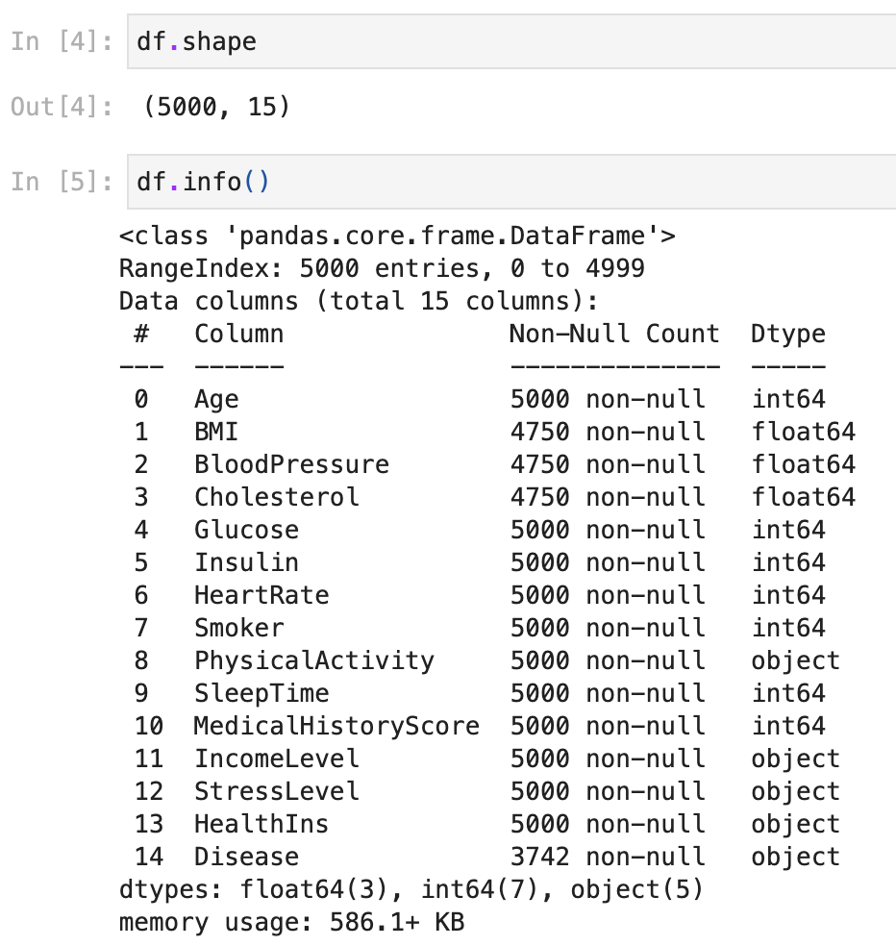

Below, I can see that the total of missing values is around 15% of the data set, without considering the characteristics of the disease, i.e. no missing values. Therefore, as we are dealing with a health data set, I don't think the best option is to replace this data with mode, mean or median, because I will insert some values that are not true, so I will choose to discard them.

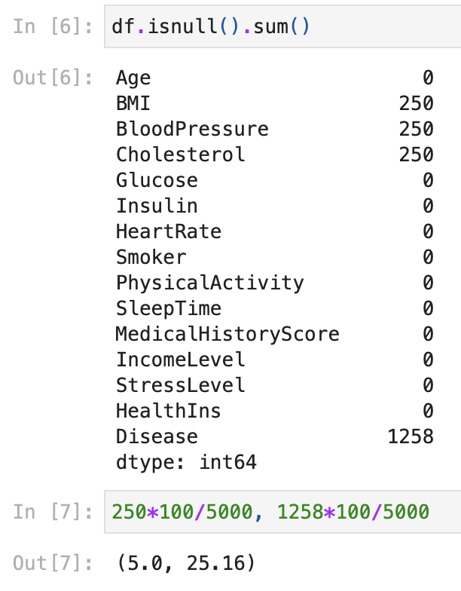

In the function below, I can see that some minimum and maximum values don't match the dictionary we have, which will result in discrepant values.

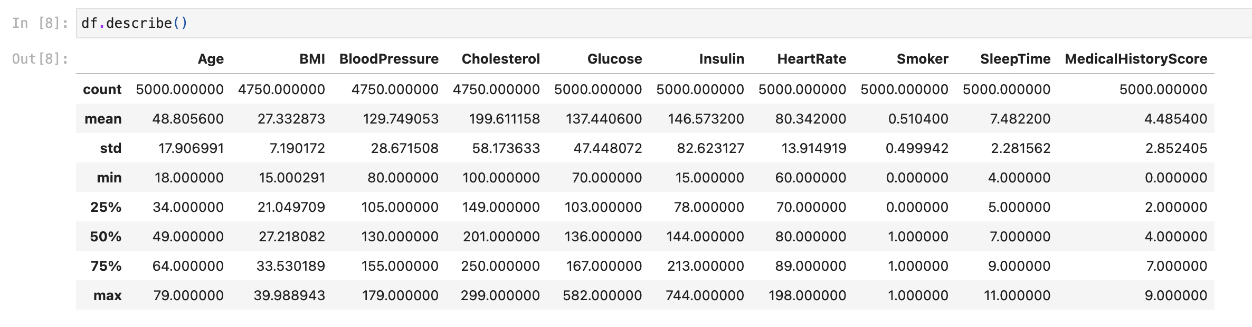

## **2.2. Missing Values**

In the next steps, I’ll delete the missing values in the features that I already saw above.



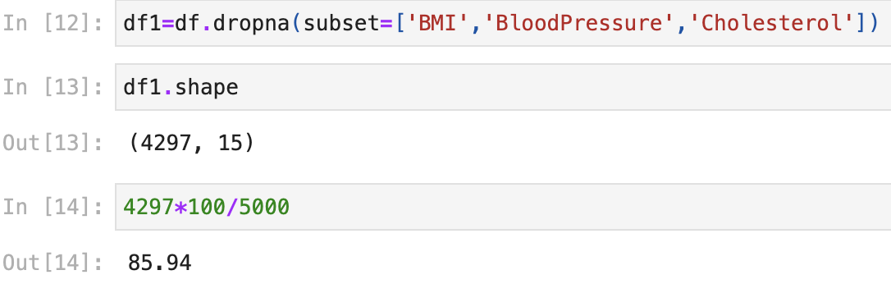

Now the size of my dataset is 4297 observations.

As seen above, we also have some null values in the disease column, which are None according to the dictionary we have, so the next steps are designed to fill in these observations so that we can visualize them better.

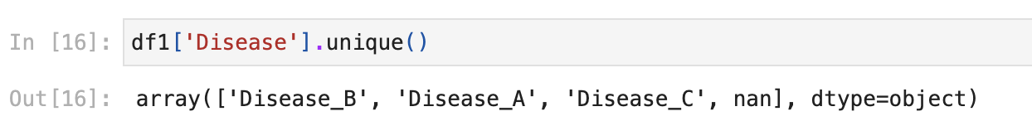



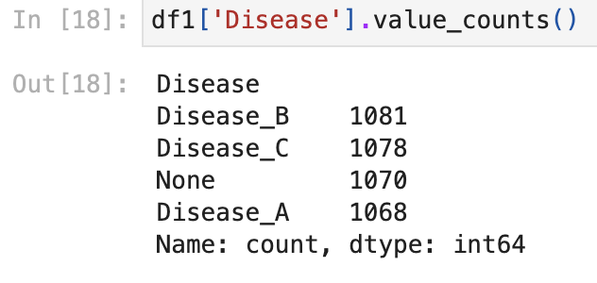

## **Rename Columns**

The next steps are just to rename the columns to a better shape.

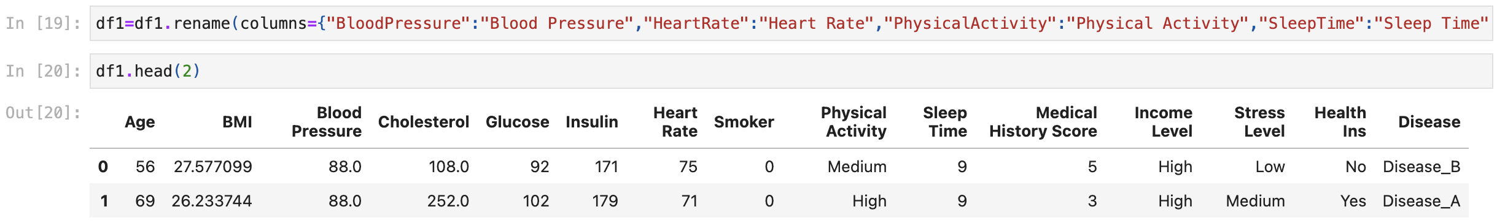

* 1. **Outliers**

As we can see in the boxplot below, we have some outliers that are easily recognized, as they differ from the range we were given in the dataset's dictionary. We have a few ways of dealing with them, excluding them, replacing them with the mean and median or even using some machine algorithm, I've done some tests and left the comments to record, after that I chose to leave them in my dataset because, as this is medical data, if I deal with them by altering the information, I will be altering our clients' data, making the algorithm unreliable, as with them I can pick up some correlation with a specific value of another variable.

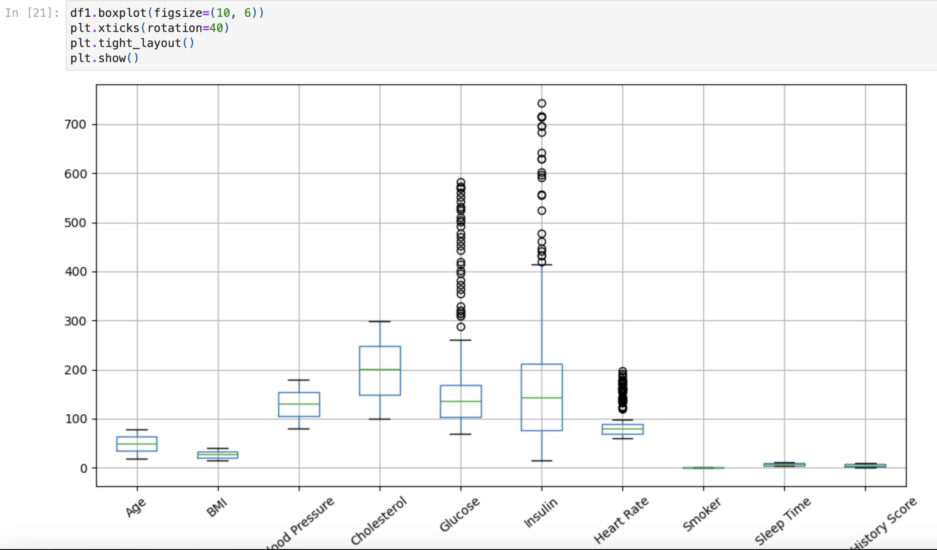

* 1. **EDA (Exploratory Data Analysis)**

I'll ask a few questions to see if I can get some insight into the type of data I'm dealing with.

- Do the people who go to the doctor the most have paid health insurance?

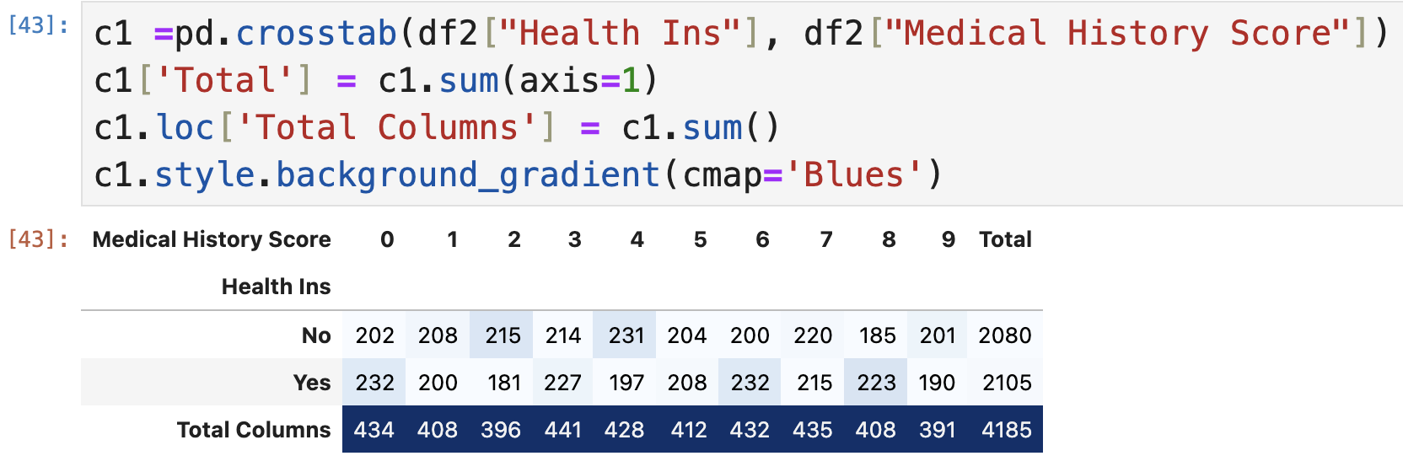

I'm going to follow the thinking of people with a score above 6, who go to the doctor the most, so we can see above,

Of these, 48.34% do not have health insurance.  
Conversely, 51.66% of them have health insurance.

These numbers show that even if the majority of people with more frequent medical histories have health insurance, there are still some people without coverage. This highlights the significance of health policies aimed at expanding access to health insurance, particularly for those who may require more intensive medical care.

- What is the income of people who pay for health insurance?

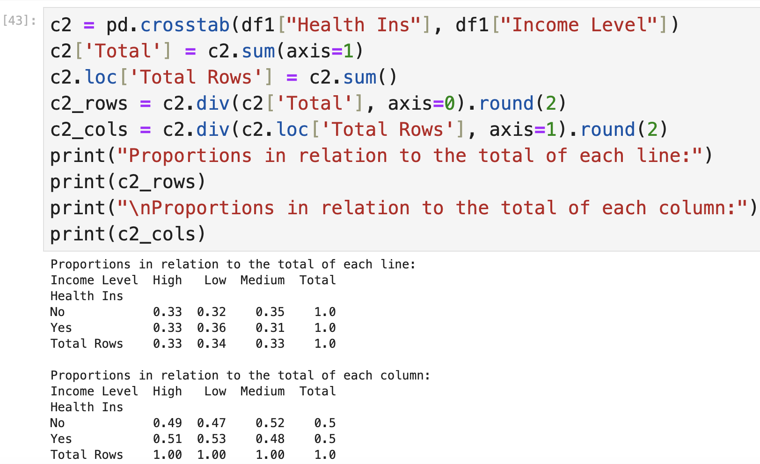

For both groups, with and without insurance, the distribution is comparatively even across all income levels. We can also see that the proportion of uninsured people is slightly higher among low-income people (53%) compared to high-income (49%) and middle-income (52%) people.

The results show that although there is a slight tendency for people with lower incomes to have less health insurance, this may mean that people with a higher level of income resort to private insurance doctors.

- Does the level of stress change according to monthly income?

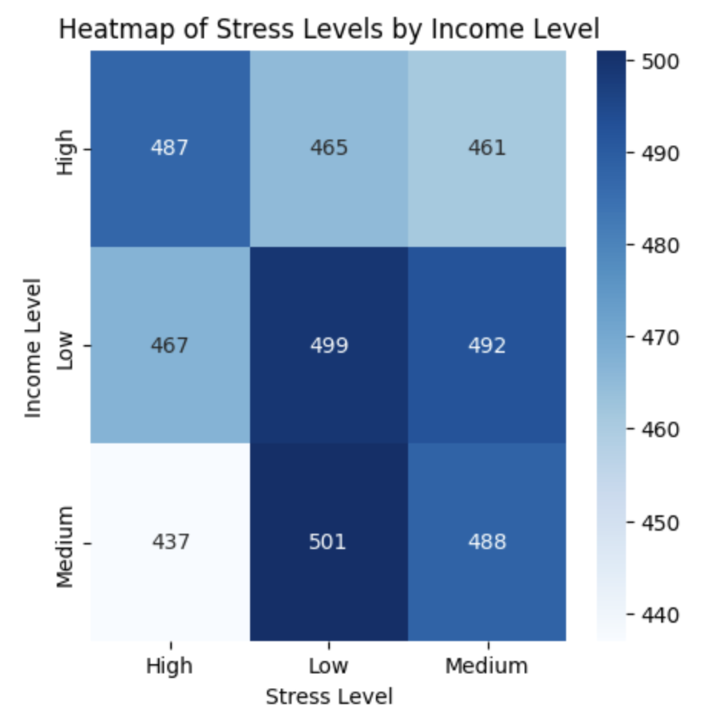

The heatmap shows us that the data is well balanced and that there isn't much variation between stress levels according to income level, so we weren't able to gain any insight from this question.

- Does the level of stress vary depending on whether the person is a smoker or not?

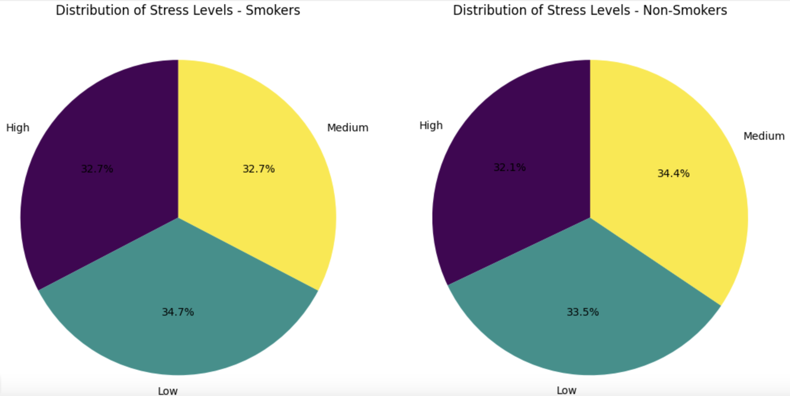

We can see a small increase in the number of relationships between people who smoke more and have a low level of stress, which suggests a scenario in which, despite practising the behaviour of smoking, these individuals do not have high levels of stress, but again, the data set is very balanced.

- What is the age with the highest number of smokers?

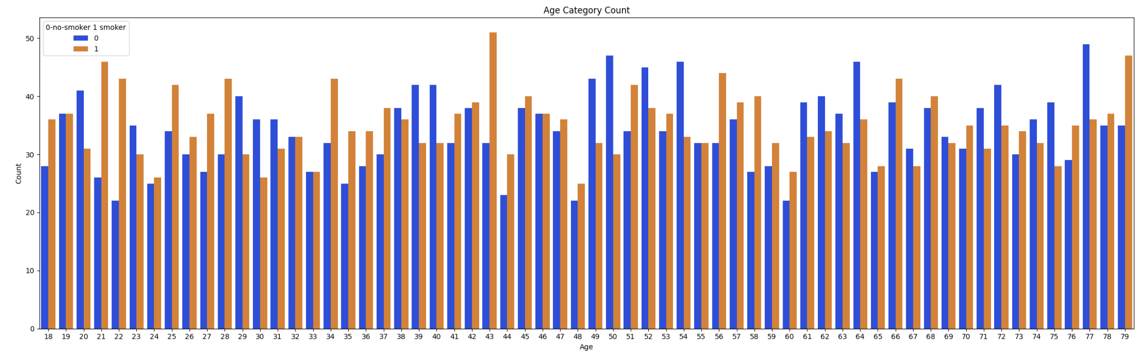

So we can see that, in this dataset, there are more smokers than non-smokers, there are approximately 50.67% smokers, but the dataset is well balanced when we look at the ages, but we can see a small increase in the number of smokers at ages 21,22,43 and 77.

- Does the level of stress vary according to the number of hours slept per day?

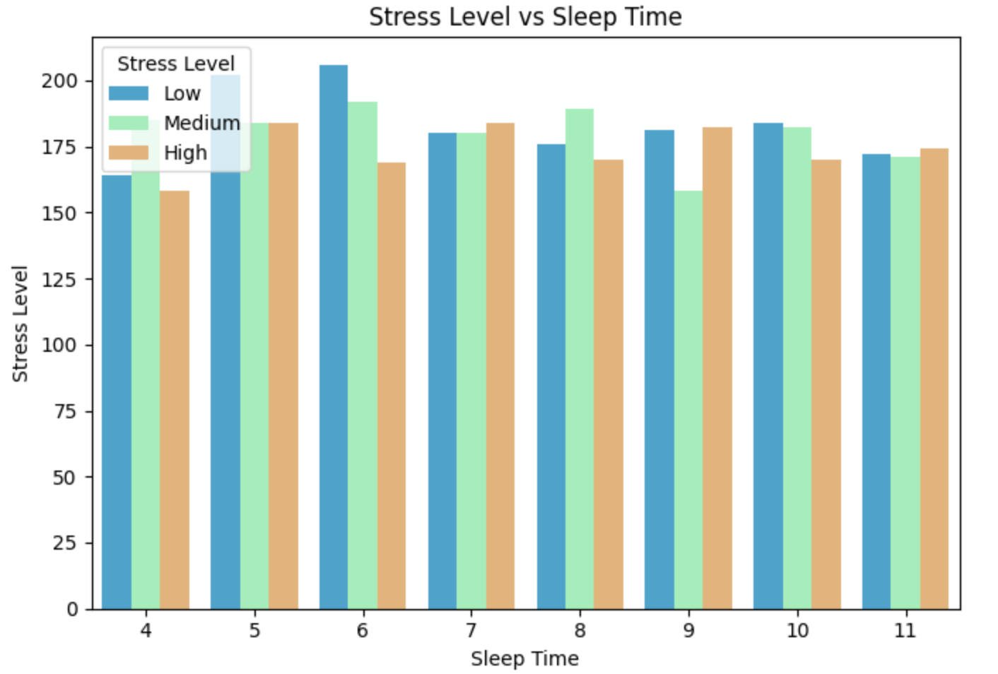

We can see that there isn't much difference in the level of stress compared to the number of hours slept per night.

I’ve plotted the Age, heart rate and blood pressure to see if there are some, but again nothing.

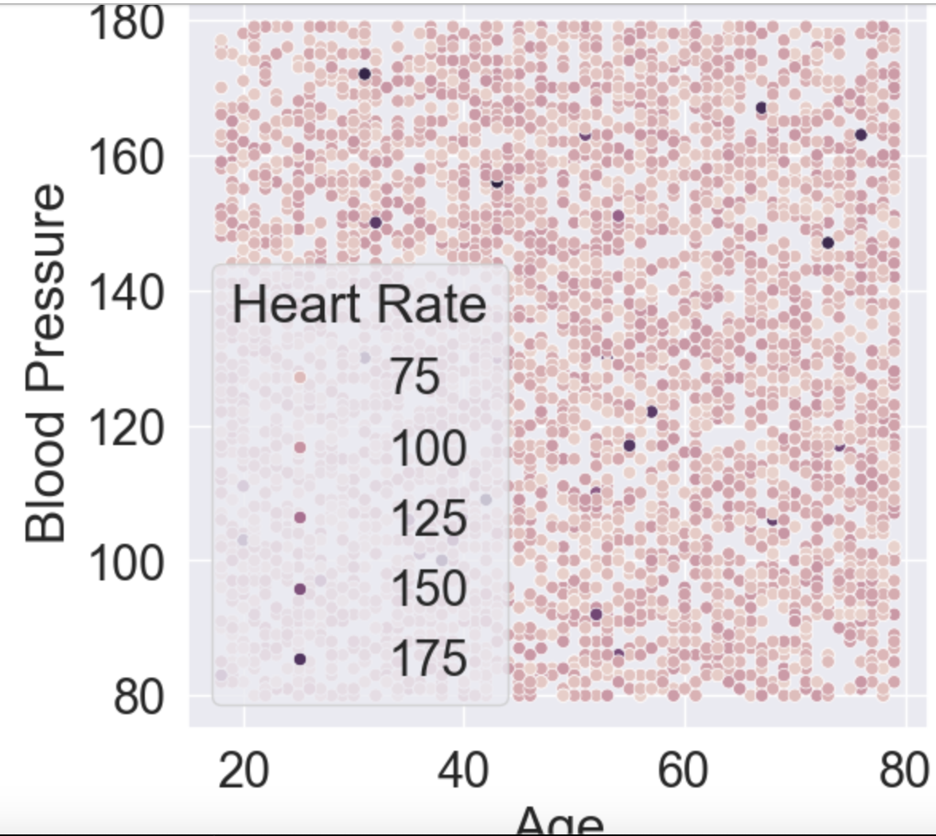

Below, I make a scatter plot to see if there is any relationship between Blood Pressure, age and Heart Rate, but again, the data set is very balanced, and I can't get any insight.

1. **Encoding**

“Data encoding in computer science is the process by which we change data from one form to another to ensure it can be effectively and efficiently processed by varying systems and applications” (Study Smarter )

In this case, I’ll choose the Ordinal Encoder because the dataset has a pattern like low/medium/hight which this is the best way to encoding.

To start, we need to import he library



Defining the order of categories for sorted columns

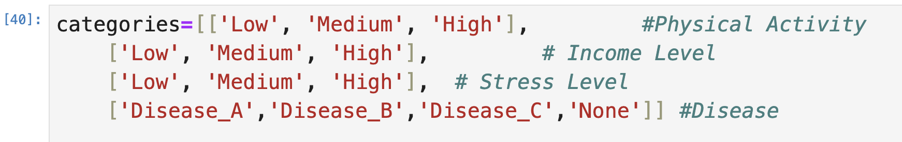

Next steps are:

- Selecting the sorted columns

- Creating OrdinalEncoder with specified categories

- Applying ordinal coding to sorted columns

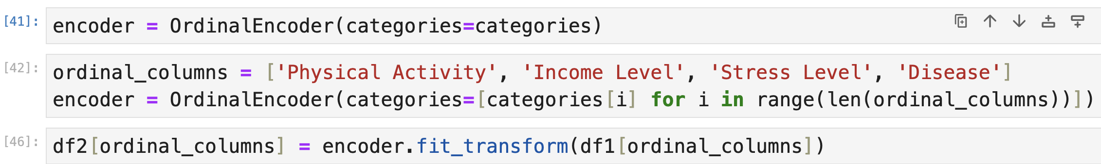

The dataset also has the binary column that is Health Ins, so I'll apply the binary coding, to check I’ll call the function head() to have a look in my dataset now

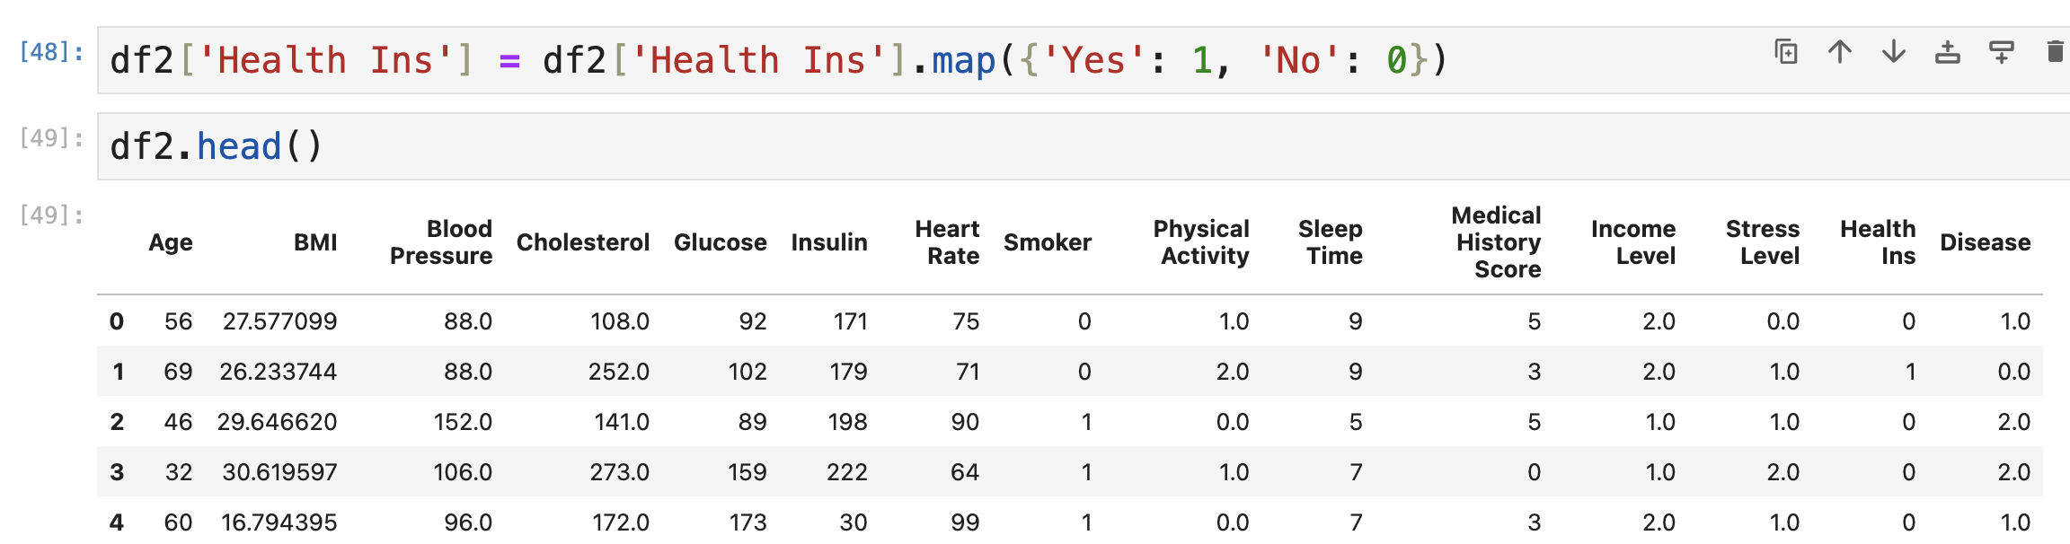

Now that I have all the numerical columns, I'll check the correlation between the features and my target, which is the disease again.

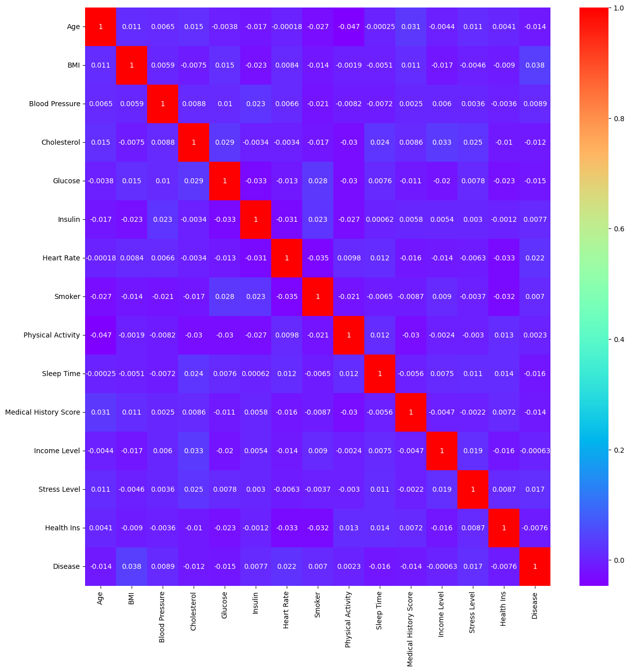

Above, we can see that there isn't a great correlation between the features, so this is something I'll need to check and understand after applying some machine learning algorithms.

** I did some tests and saw that if I drop the columns below my dataset I'll get better accuracy, and we can see in the heatmap above that these two columns are the ones that have the least correlation with the target, so I decided to drop them.



1. **Scaling**

“Feature scaling is a data preprocessing technique used to transform the values of features or variables in a dataset to a similar scale. The purpose is to ensure that all features contribute equally to the model and to avoid the domination of features with larger values” (Bhandari)

To find out which sizing technique is the best option for my data set, I will apply a comparison of techniques to be sure of my decision.

I'll start by importing all the necessary libraries and then create a list of the columns to which I want to apply the technique and another list of all the dimensioning techniques.

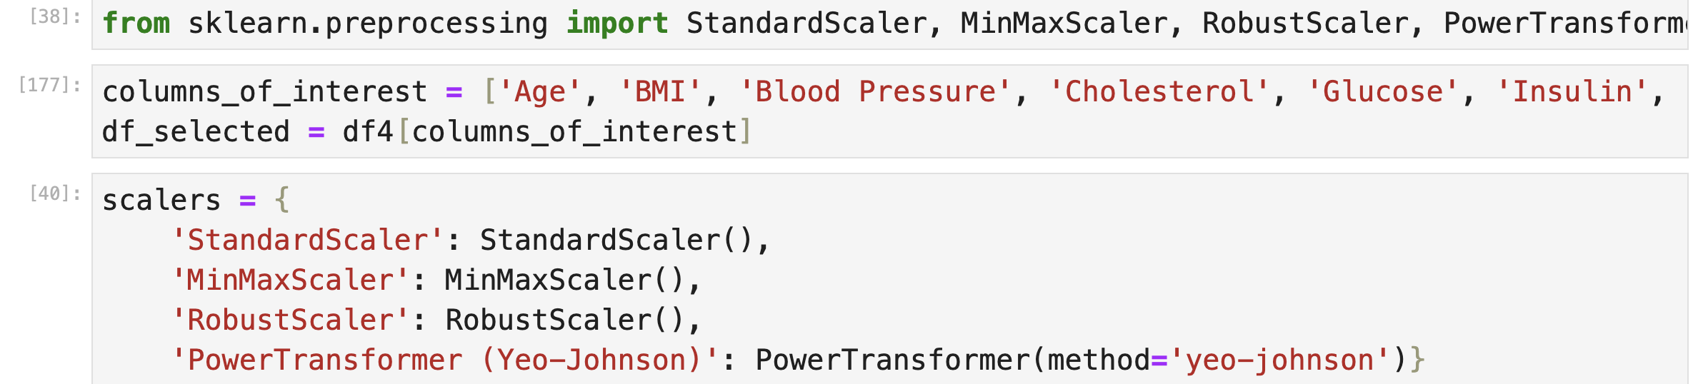

I'll apply some scaling technique to the columns I've selected and then store the scaled data in df_scaled to plot my result.



The next steps are to plot my output from the sizer above.  
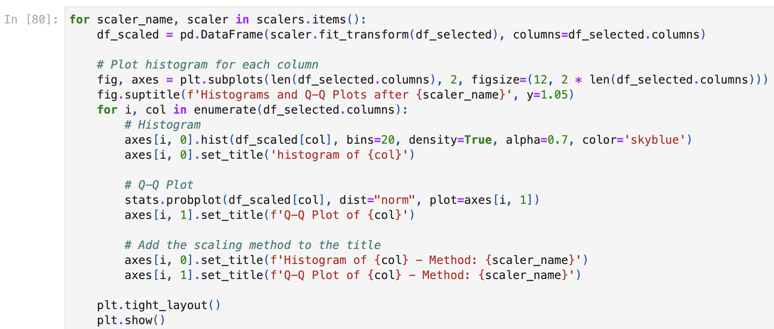

I'll put here the graph of the scaling method that gave me the best result.

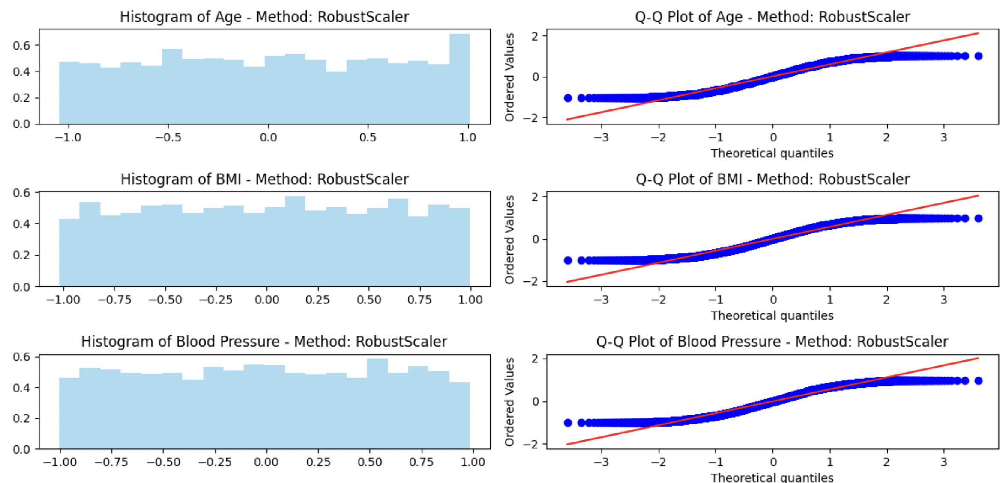

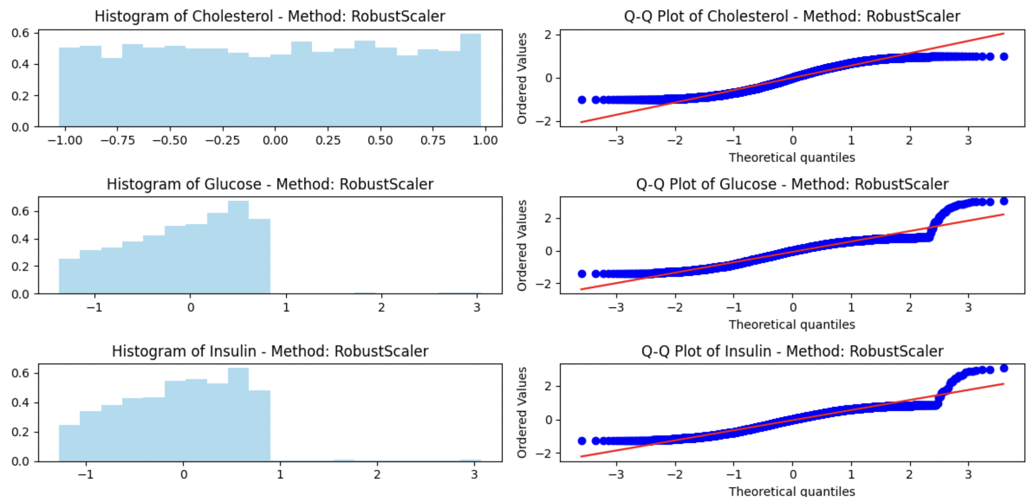

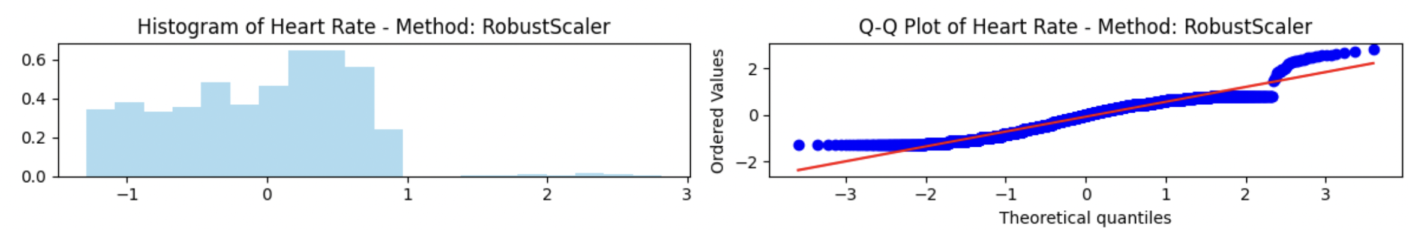

As we can see the best option for scaling this dataset is the Robust Scaler, because is a technique used to scale features of your dataset in a way that is less sensitive to outliers.

** I've tried using MinMax, Standard Scaler and Power Transformer to see how accurate my PCA is and the best option is Robust Scaler, but I've left it “commented out” in the dataset to keep a record.

I'll create the list with the columns that I'll scale



The next steps are to apply the sizing to the columns I've selected.

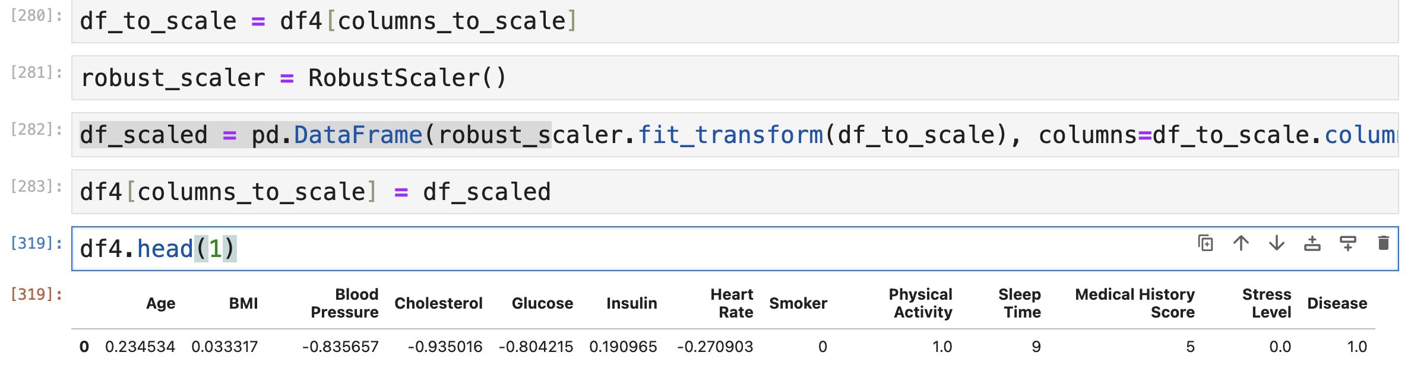

1. **Dimensional Reduction: PCA vs LDA**

**5.1. Principal Component Analysis (PCA)**

I will use PCA module of sklearn library to perform PCA.

Before applying PCA, I will exclude the target label "Disease" because of the sense of PCA, we only apply it over independent variables.



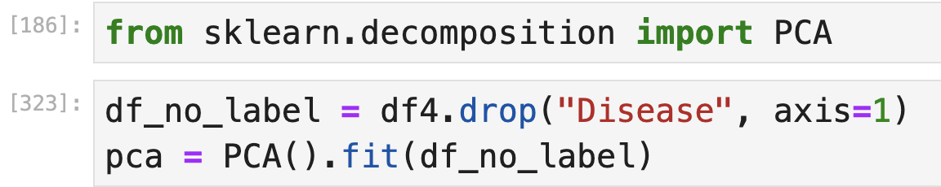

I will look at the cumulative explained variance for each number of features to determine the ideal number of PCA dimensions. I'll use the explained_variance_ratio function to accomplish that.   
The percentage of variation explained by each chosen component is returned by that function.

I will plot a line chart to see the cumulative explained variance ratio for the number of features.

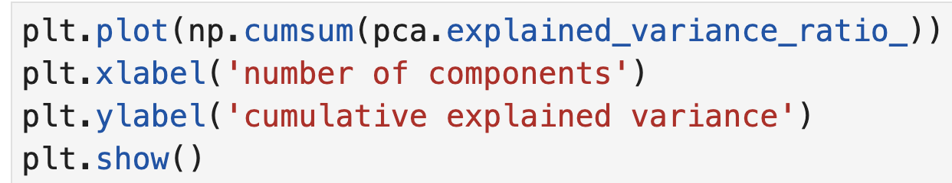

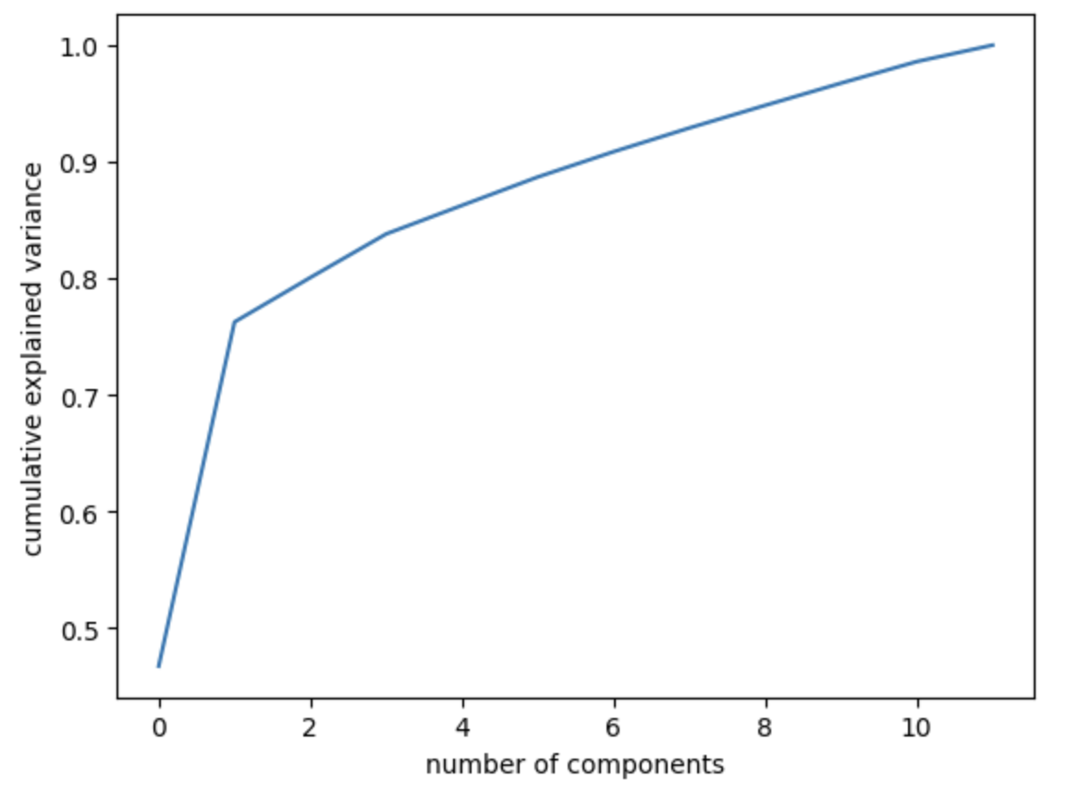

As can be seen in the figure above, we won't lose a lot of information if I set the PCA's maximum number of features (dimensions) to 8 because the cumulative explained variance hovers around 92%.

Now I will apply PCA with 8 dimensions over my data.

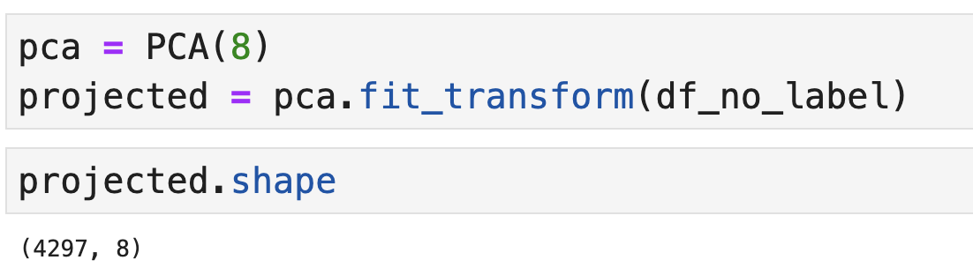

Now, my data has 8 features that keep all the information that the original 15 columns have.

I'll create a new dataset with the information of the 8 features.

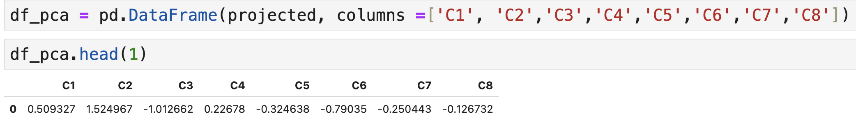

Now, add my target with the PCA dataset, followed by the sum of the PCA ratio to see how much it is covering in my dataset.

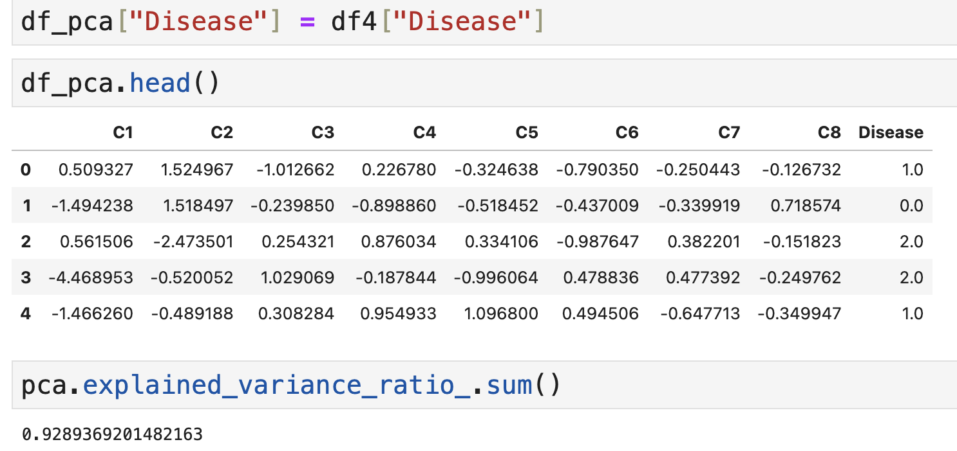

* 1. **LDA (Linear Discriminant Analysis)**

"Linear Discriminant Analysis can be used to perform supervised dimensionality reduction, by projecting the input data to a linear subspace consisting of the directions which maximize the separation between classes" (Scikit Learn)

I'll start by dividing my data set into two: X, which will be my target, and y, which will be the entire data set minus the target.

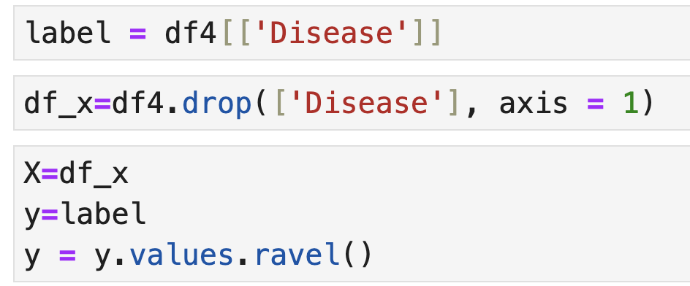

Import the LDA library for the sklearn.

I've tested with 2 components and with 3, and I got a better variance ratio with 3, so I'll follow that way.

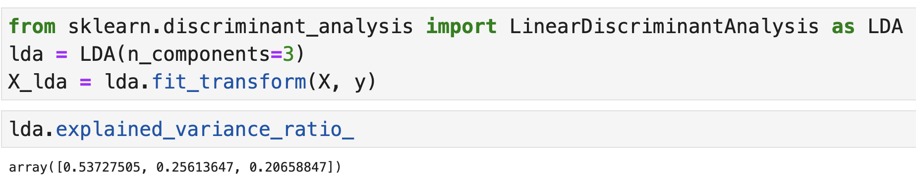

Now I'll plot my LDA.

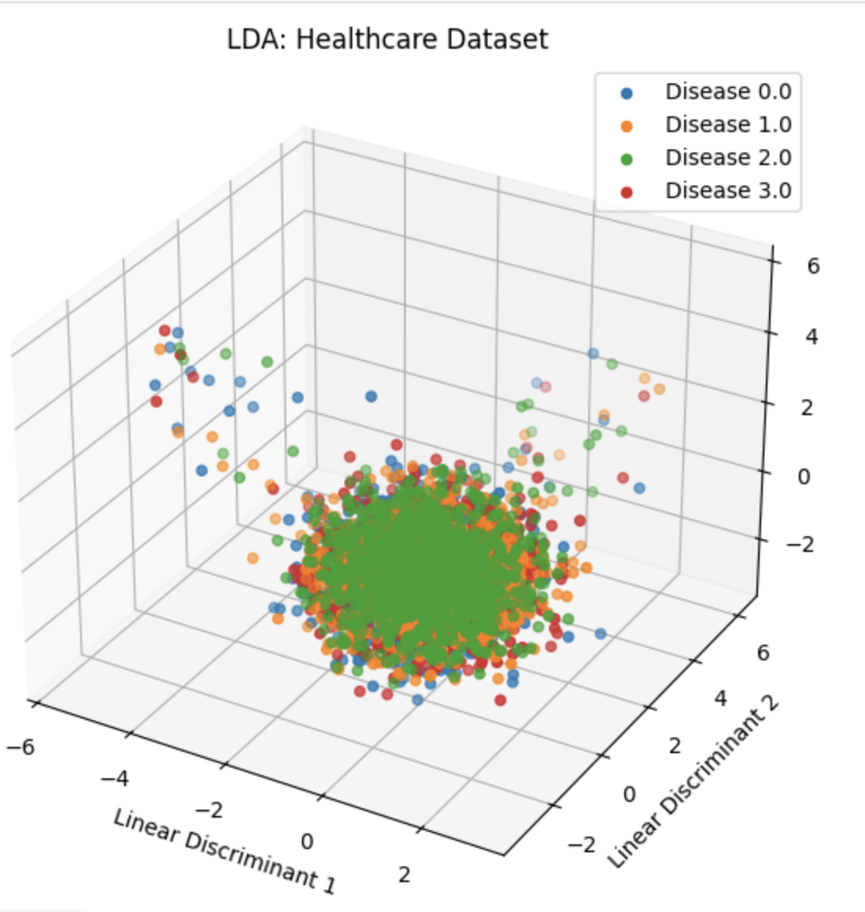

As we can see in the graph above, Disease_2, which is Disease_C in the original dataset, overlaps with the other Diseases. This may be because LDA may not have been able to find components that separate the classes well, we can see this in the course of data exploration, which has always been very balanced and hard do get some insights.

* 1. **Accuracy PCA and LDA**

The next steps are to apply the linear regression model in my dataset, just to have a look at the accuracy of the LDA.

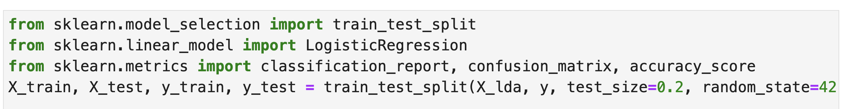

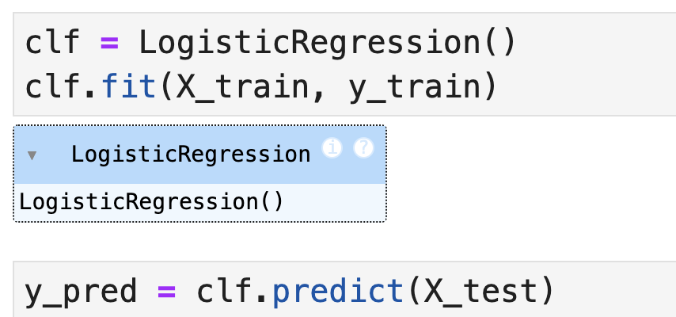

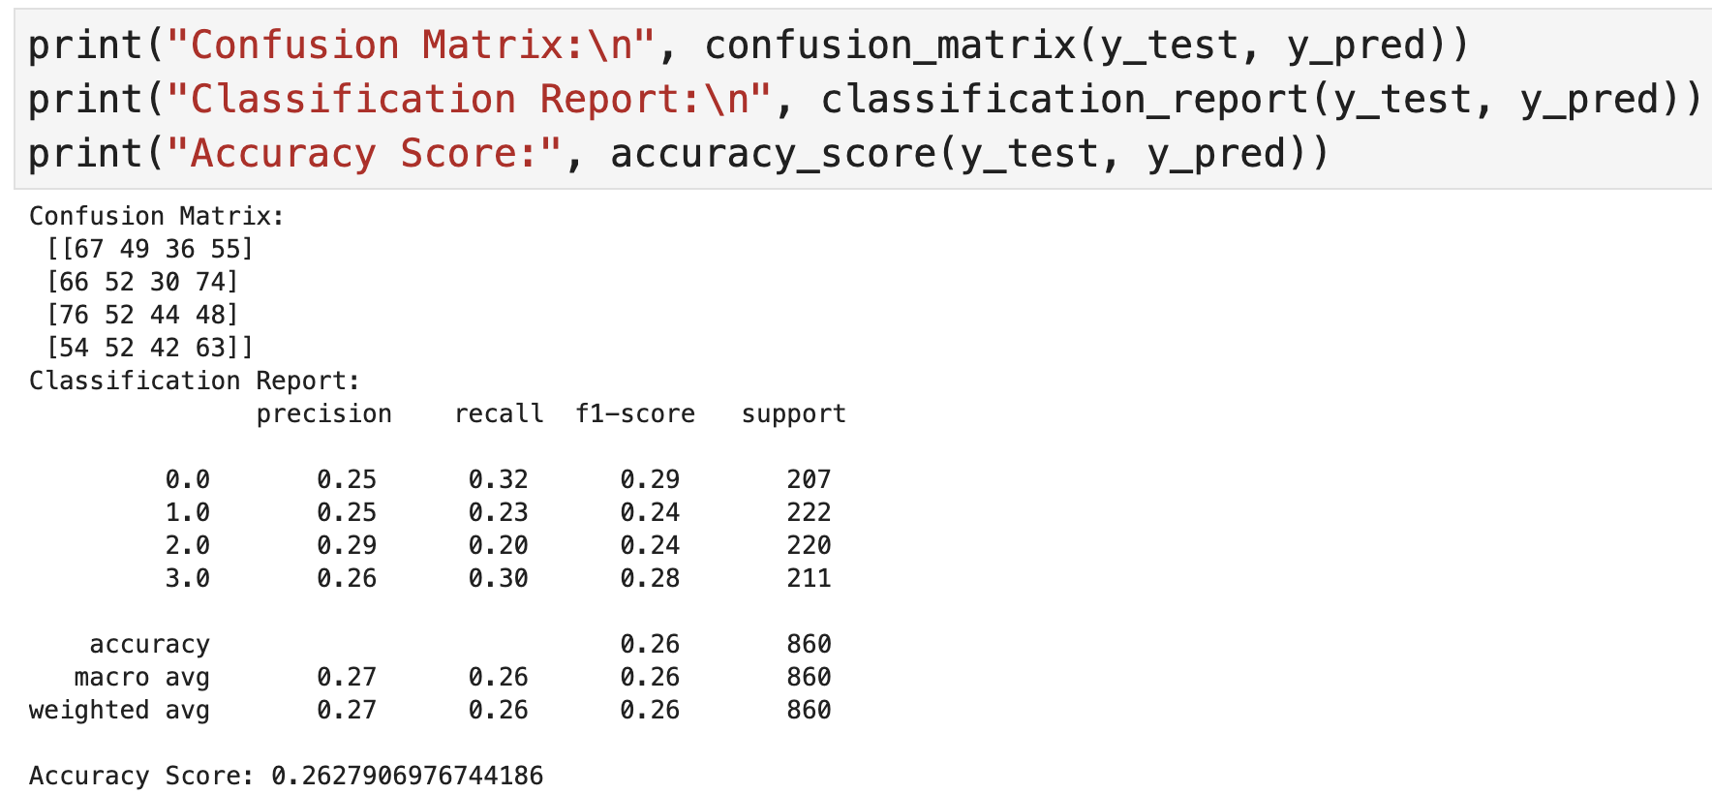

Accuracy of 26,27%, it is very low, followed by low precision and low recovery, which means that LDA is not suitable for capturing the complexity and separation of the classes present in this dataset.

Now I’ll apply some machine models in my PCA, to see the accuracy.

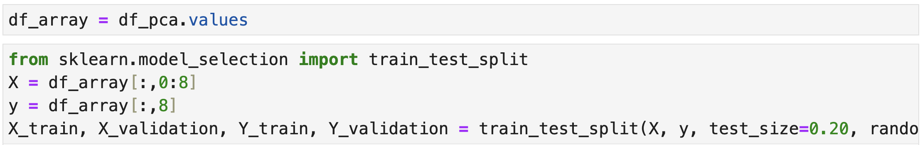

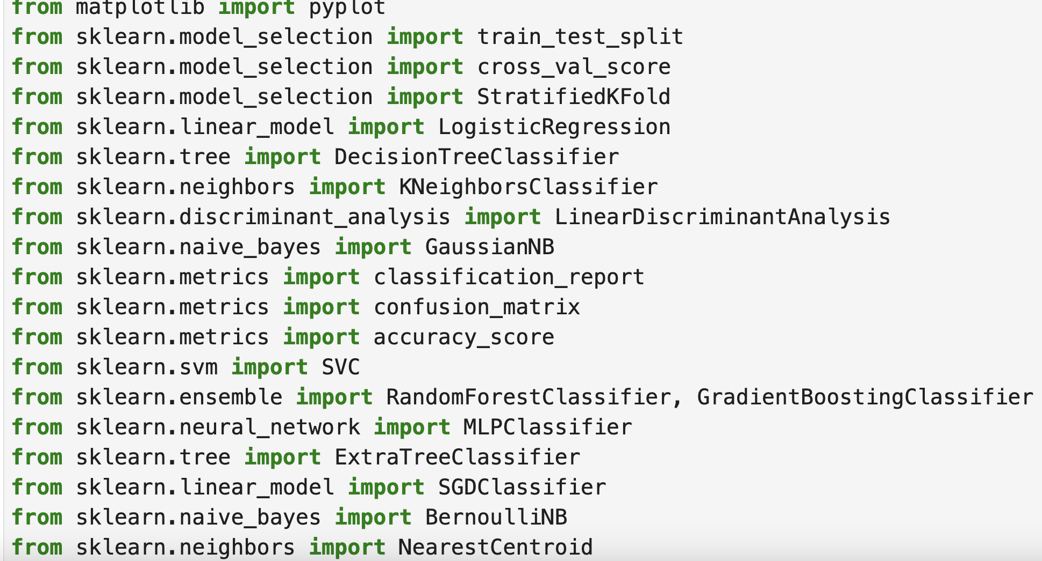

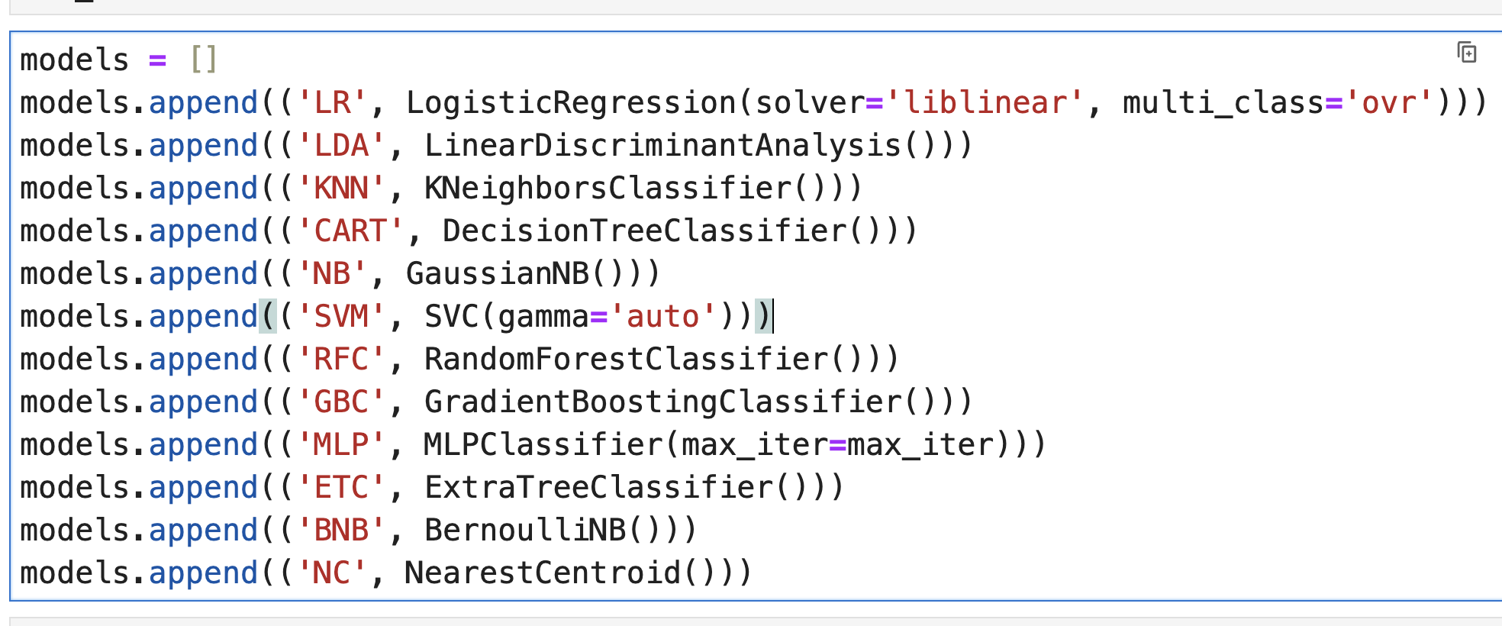

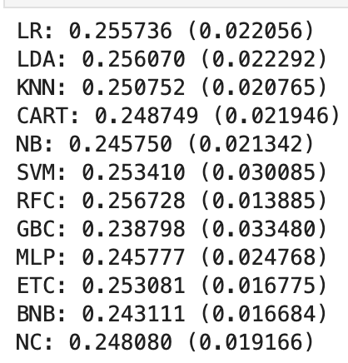

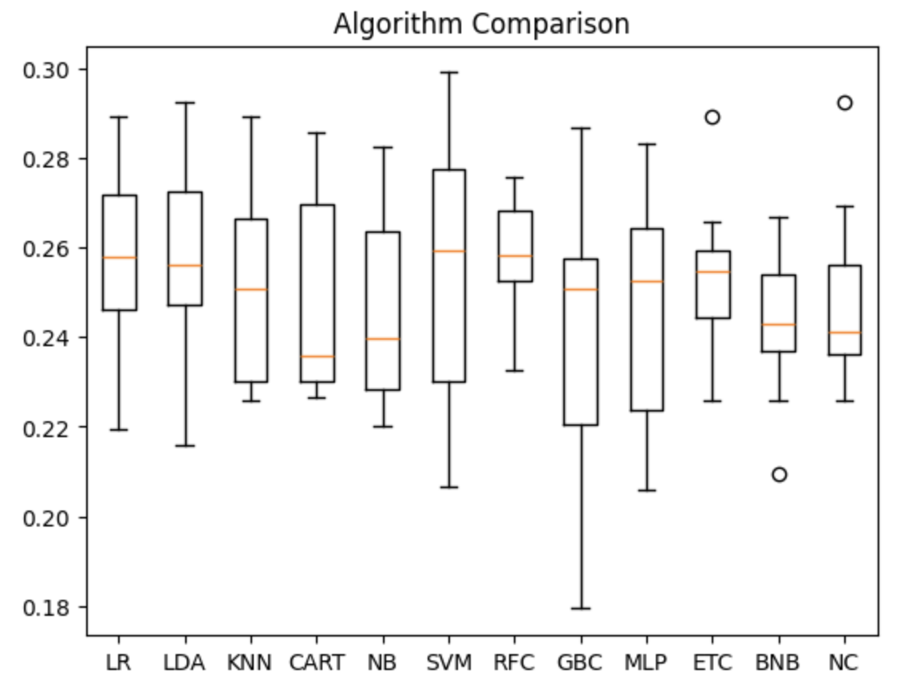

Again, the accuracy is very low for the machine model that I’ve applied.

1. **Data Preparation conclusion**

The dataset that was used in this project was about a healthcare organization that contains patient demographics, health metrics, treatment details, and follow-up outcomes across multiple departments. The main goal of this project was to explore, get some insights and preparing it for the machine learning models in order to improve treatment outcomes and predict which Disease the patient may have.

First, I started by exploring the data to characterize it. I identified the number of features and rows, as well as the types of values in the data, and then detected the fact that some columns have some missing values, so I converted them to None, so that I could easily exclude them from my dataset.

After that, I checked the outliers in the dataset, because they can affect some machine learning models, and there are some, but after doing some tests, I decided to keep them in the dataset, because they are medical data and if I deal with them by changing the information, I will be changing the customers' data.

Before applying dimensional reduction, I did the coding and sizing on the dataset and applied a heat map test to see if there was a correlation between some features, and there wasn't, to get a better result I chose to exclude two features, so in total my dataset has 4,297 rows and 13 features. More reliable and effective dimensionality reduction can be achieved by using PCA or LDA, particularly in datasets with a large number of features and classes (targets). LDA can concentrate on optimizing the separation between classes, whereas PCA can help prepare the data by eliminating noise and simplifying the data.

But in this dataset, none of them works well, we got an accuracy very low which can be explained by the structure of the data, in which the relationship between features and classes is not captured by linear techniques or even by dimensionality reductions.

1. **Machine Learning**

As we saw when preparing the data, the healthcare dataset has a target which is “Disease” and, when we have a target, we generally use supervised learning models as it works by training inputs to outputs that can be used to predict new datasets by an existing one that has already been trained. Supervised learning makes it easier to interpret the relationship between the features and the target and provides direct feedback during training, but on the other hand, it needs a large amount of labelled data and runs the risk of overfitting. As for unsupervised learning, used on unlabeled data sets, it is good because it can identify unknown patterns or groupings in the data, but the results can be more difficult to interpret and may not be directly usable for prediction.

**7.1. Split, train and test**

Using the function head, to see my dataset again.

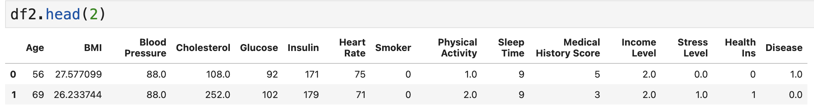

The next two steps are to split my dataset into independent columns (X), and dependent column (y), followed by train and testing the data.

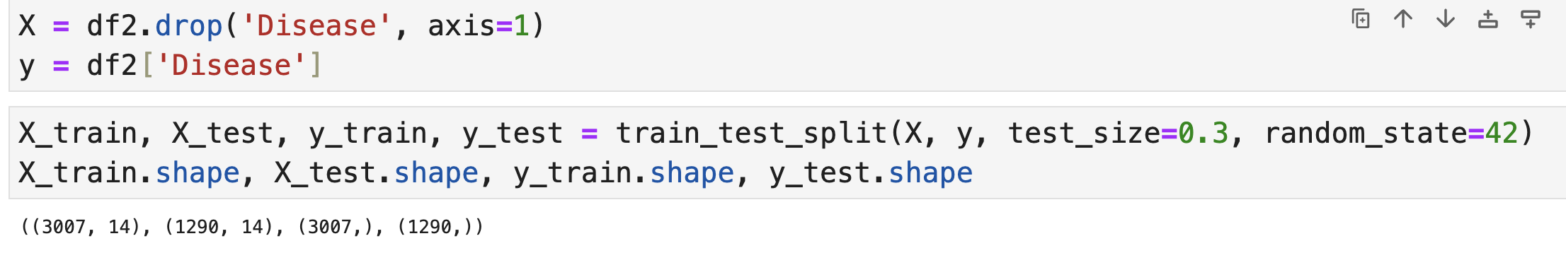

* 1. **Feature Importances**

*"We use the term feature importance to describe how important the feature was for the classification performance of the model. More precisely, we refer to feature importance as a measure of the individual contribution of the corresponding feature for a particular classifier, regardless of the shape"(Saarela and Jauhiainen)*

In this case, I chose to use the Random Forest method to identify the most important resources in our data set.To begin with, I'll apply the model to my data set, which is already divided into dependent and independent variables, and then I'll apply the feature's importance and plot the graph to get a better view.

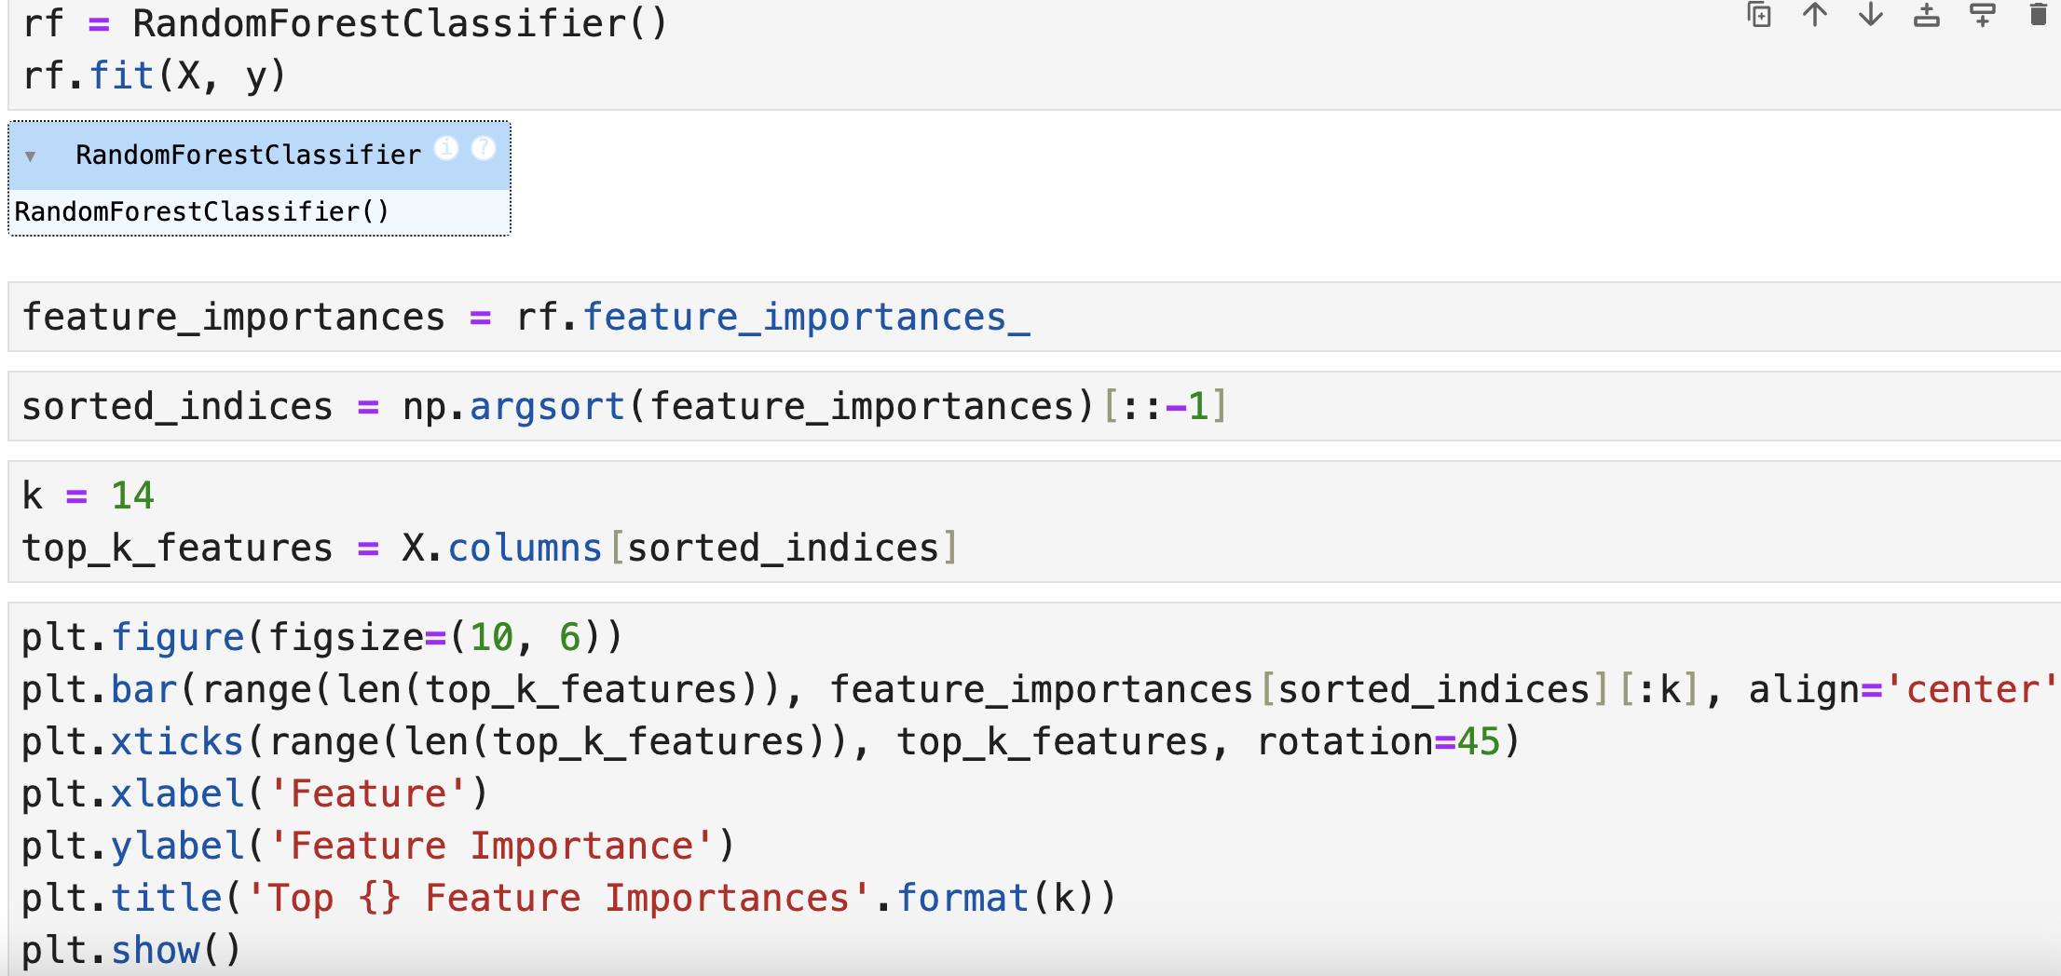

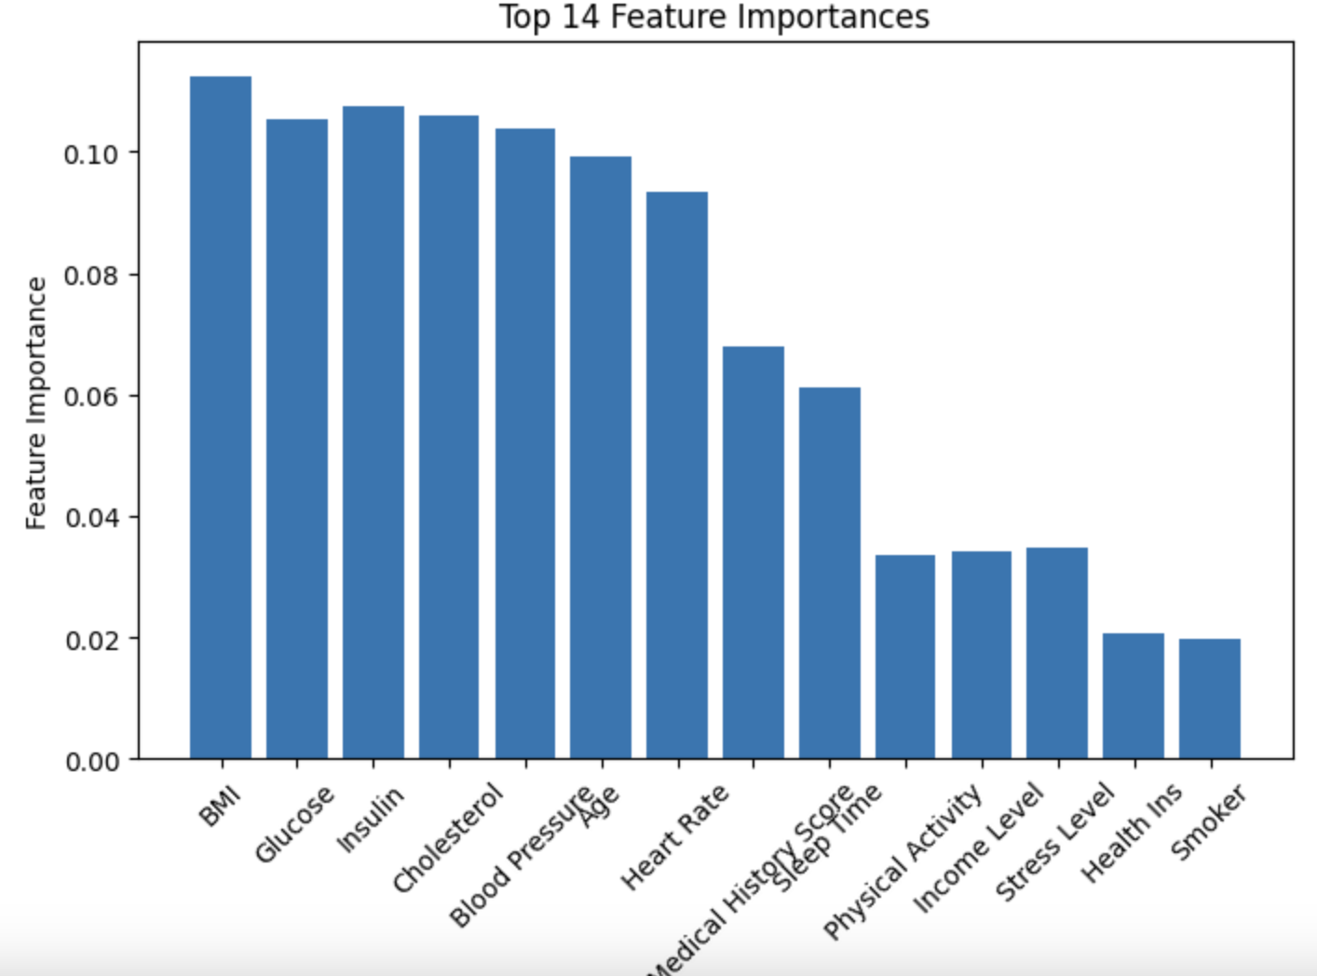

We can see that the first 7 columns have practically the same importance for the machine learning model, these columns are variable types as we have already seen in EDA, in some cases if we use only the most important features we can simplify the learning model, increasing accuracy and reducing overfitting.

* 1. **Hyperparameter**

*"In the context of machine learning, hyperparameters are configuration variables that are set before the training process of a model begins. They control the learning process itself, rather than being learned from the data. Hyperparameters are often used to tune the performance of a model, and they can have a significant impact on the model’s accuracy, generalization, and other metrics"(GeeksForGeeks)*

I'll start using the GridSearchCV which helps in the process of performing the hyperparameter to determine the optimal values.

First of all, importing the necessary library, followed by defining the hyperparameter grid to test.

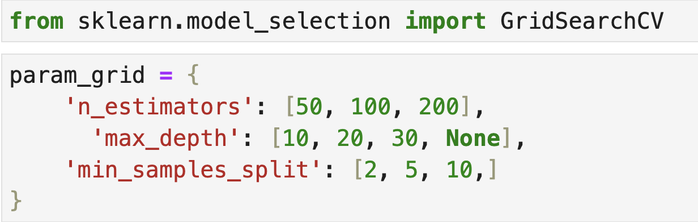

Applying the GridSearchCV in the Random Forest model, to check the accuracy.

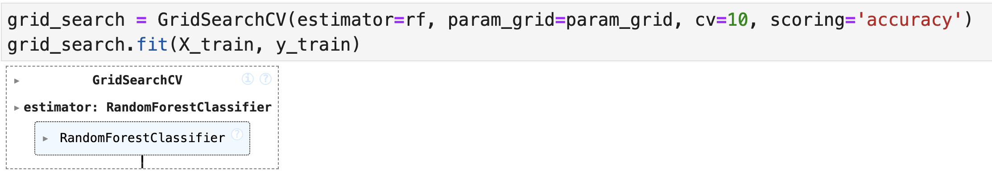

Get the best parameters and best accuracy, and print them.

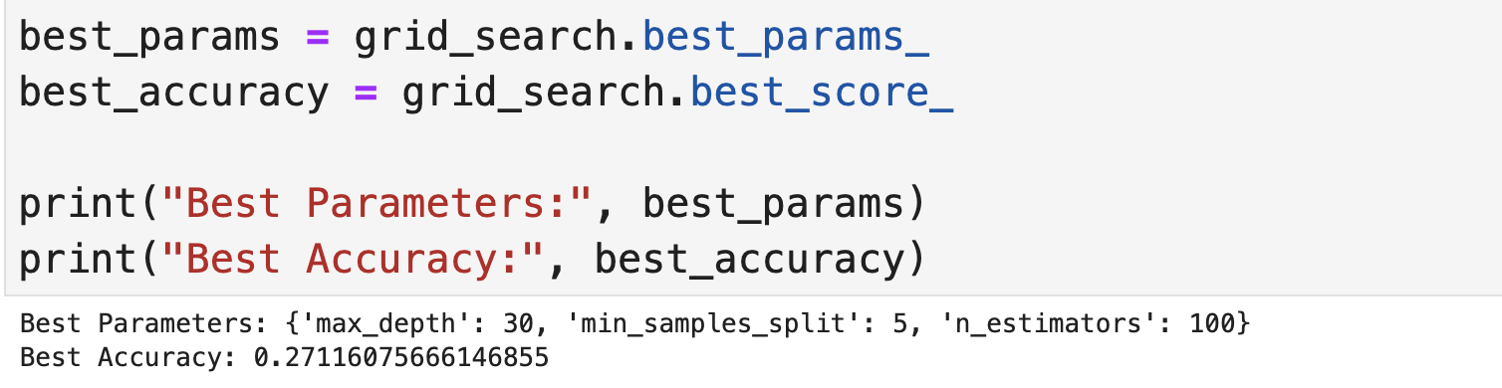

How the accurancy is not good, I'll try another way of Hyperparameter tuning, which is Randomized Search CV.

The next steps are the same that I did for the Grid.

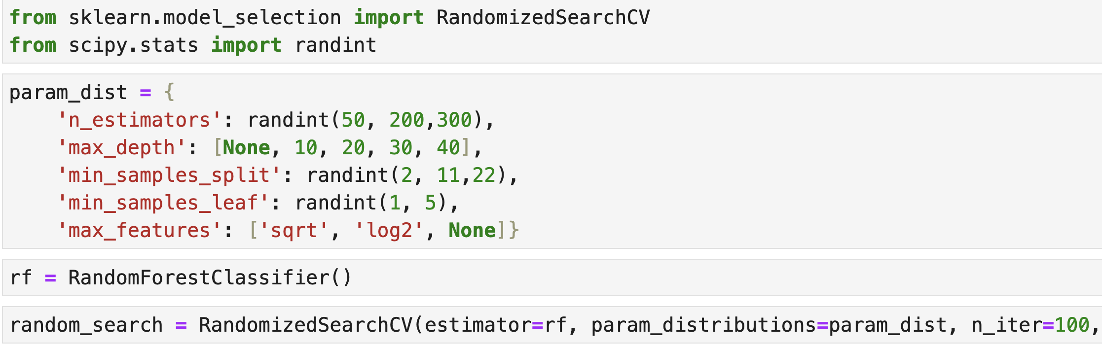

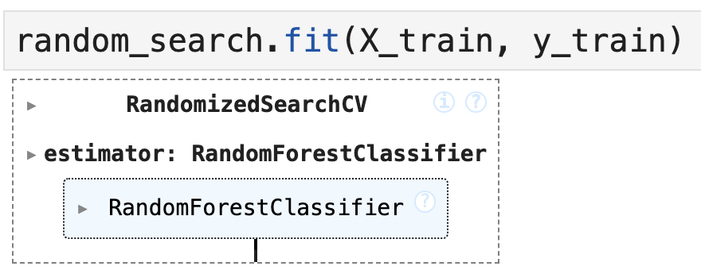

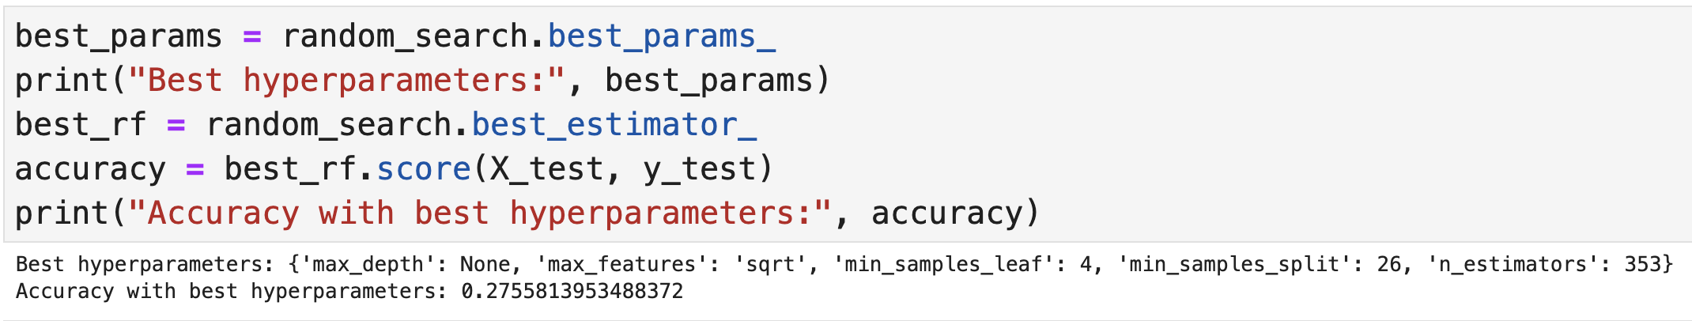

Both hyperparameter tuning models have low accuracy, I tried some tests within the Random Forest itself, changing the parameters informed in the Grid and Randomized, but I didn't see much improvement in accuracy, and always takes too much time to load the changings, I also tried to apply these two hyperparameter tuning models with other machine learning models, but I believe that because it is a large dataset, and the other models are more robust, I didn't get any results, because Python kept loading for more than 30 minutes, I left a comment on my notebook to serve as a record, as I didn't get much improvement I decided to move on to the machine learning models without applying any hyperparameter tuning.

* 1. **Training and Testing the Models**

I will make two different splits of the data set, 30/70 which means 30% test and 70% train, 20/80 which means 20% test and 80% train.

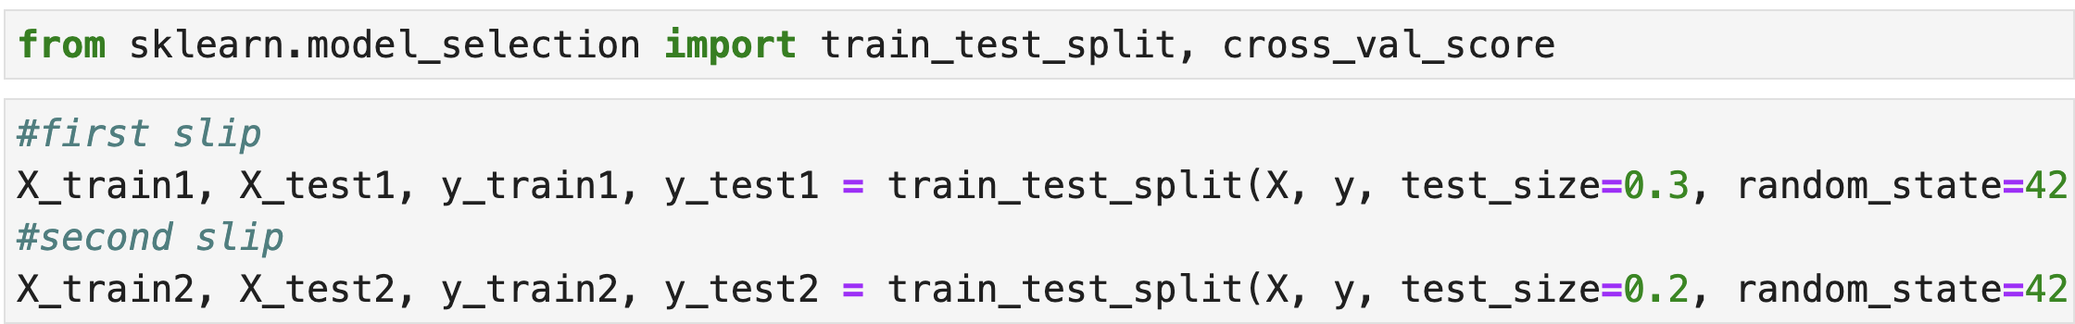

Again, I’ll import some libraries.

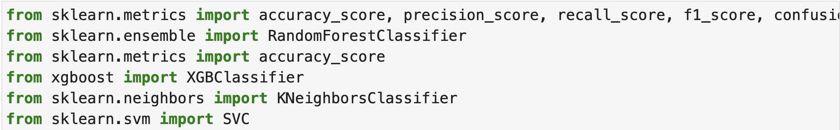

The next step are a def code, to make an ease correlation between the two splits tests, to see which one is the best option to follow with the machine learning mode, I’ll fit the model, and then predict for test data, and return classification metrics, after this I’ll create a data frame comparing my 5 chosen models, and then I’ll use my two slips tests, with the machine learning models, and print the outputs with the tabulate code.

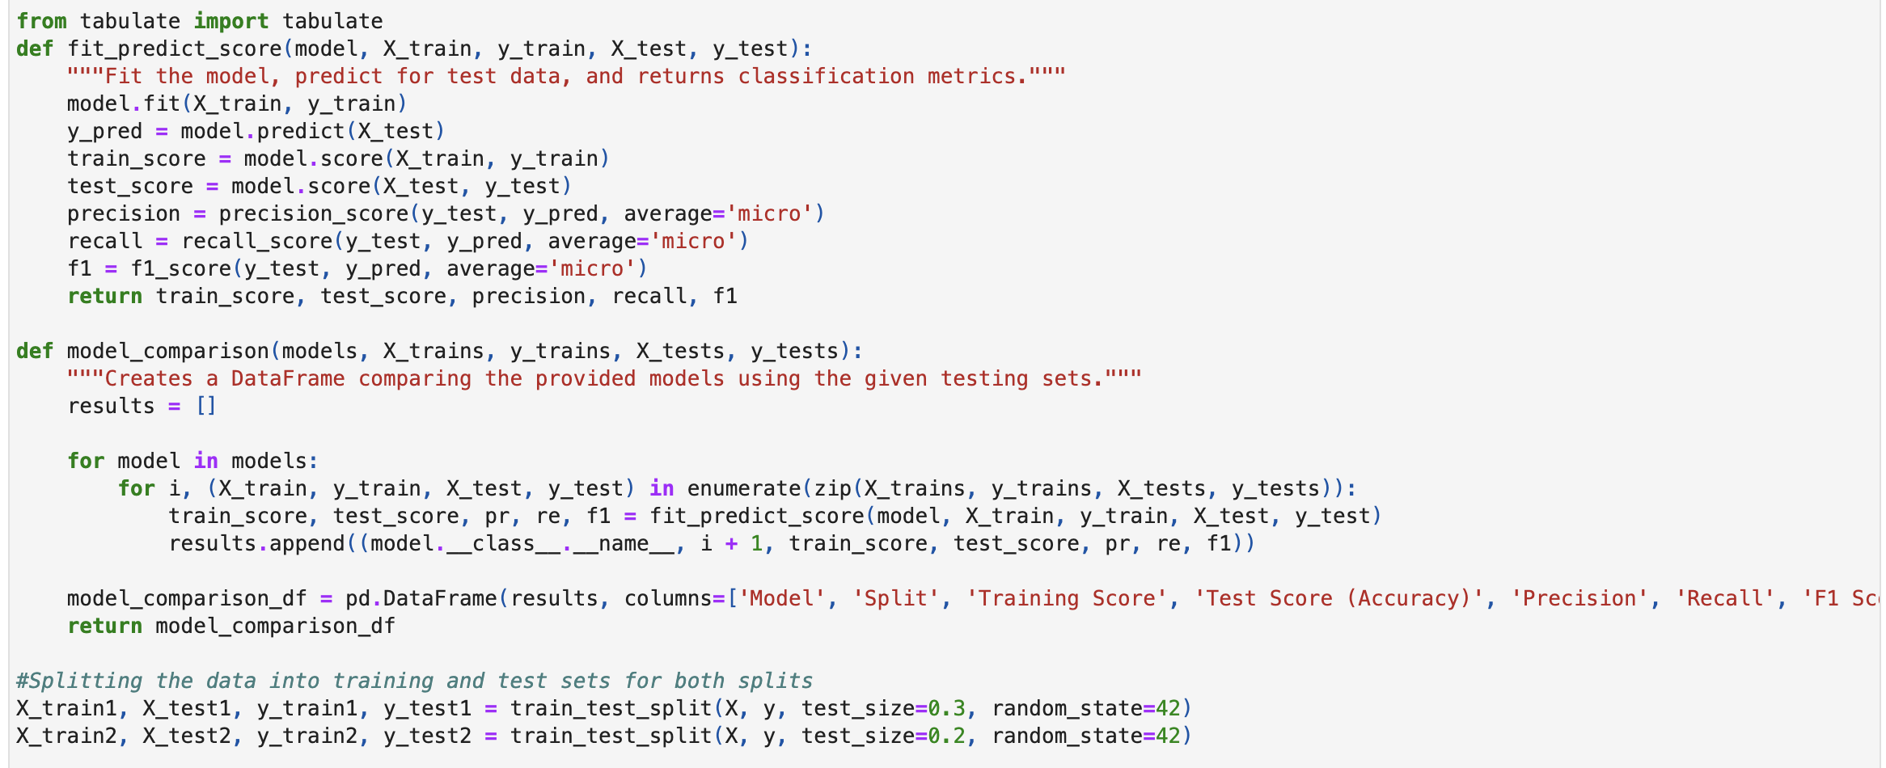

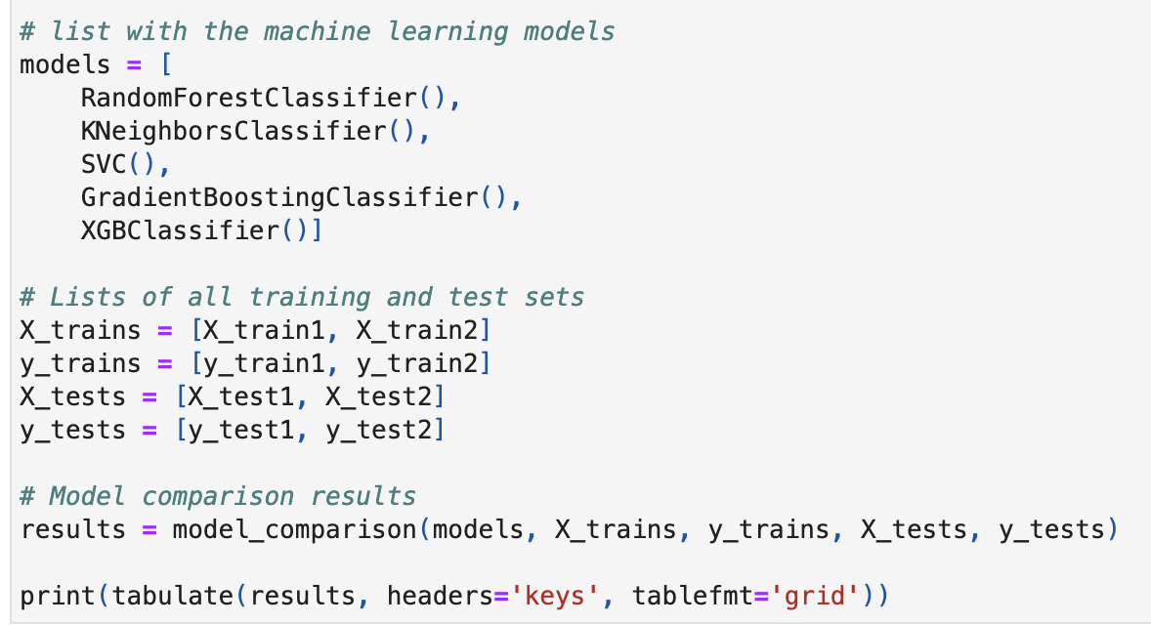

Output:

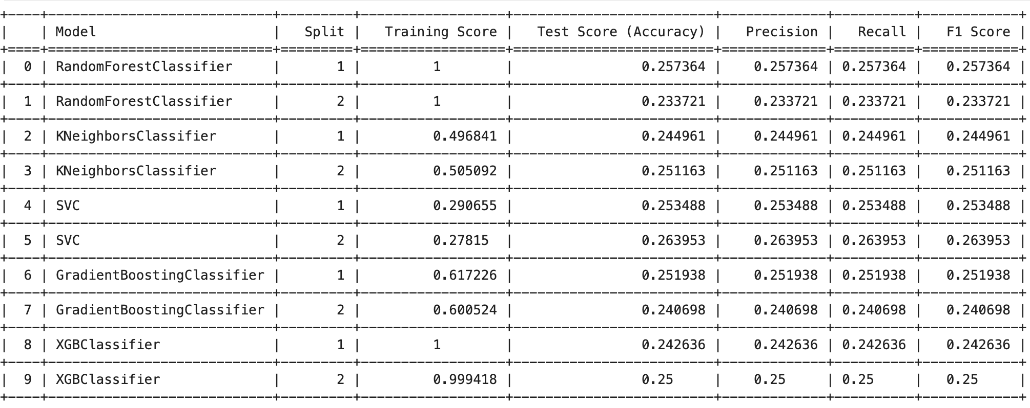

Let’s understand these results:

Training scores are the accuracy of the model with the training data.

Test Scores are the accuracy of the model with the test data.

Precision, recall and F1 Score are they are like extra measures to check the performance of the model, they work better with imbalanced data, but that is not our case.

If we take a look at the Random Forest classifier, we see an excellent training score of 1.0 in both divisions, but on the other hand, the test scores are very low, 0.25 and 0.23, which means that this model has been overfitted, which happens when a model fits the training data very well, even capturing its random fluctuations. We can see that almost the same thing happened with XGB Classifier: great training scores, but low test accuracy.

In the other three models, we can see low scores in training and testing, which means that the model does not fit the data set well.

In some cases, if the environment in which the model will be applied is very similar to that of the training data, the impact of overfitting may be less, so I’ll try apply a machine learning model to see if I’ll get a good prediction.

* 1. **Random Forest Classifier**

I'll do a test using X_train and y_train to see if the prediction is correct or not.

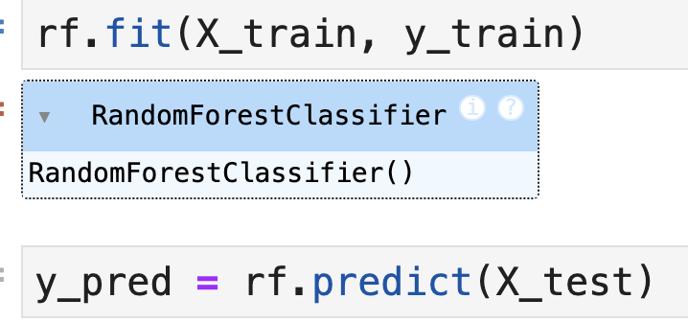

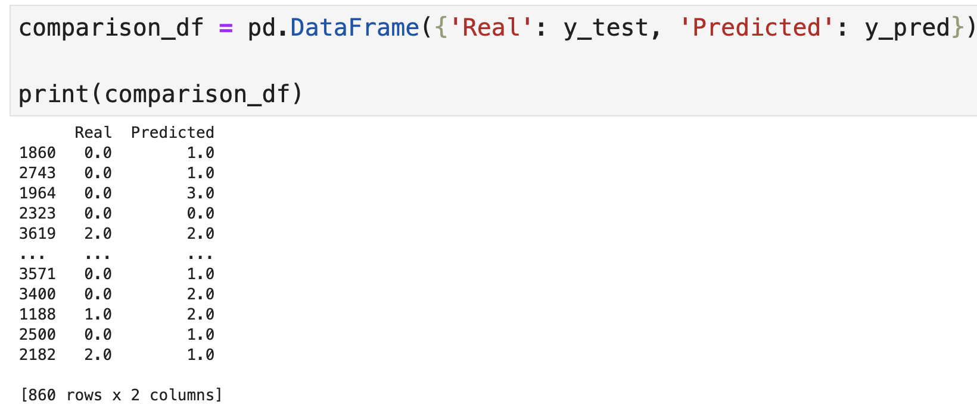

We can see that, in reality, Random Forest machine learning model doesn't make a good prediction.

## **SVC (Support Vector Classifier)**

I'll try to apply the SVC machine learning model to see the forecast.

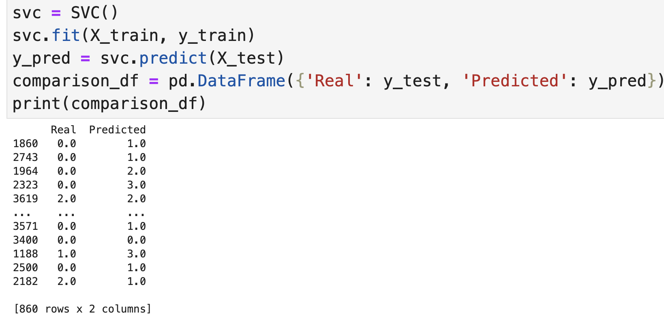

SVC machine learning model doesn't make a good prediction.

1. **Machine Learning Conclusion**

As we saw in the data preparation, using PCA and LDA wouldn't be the best choice for this dataset, so I chose to use the original dataset, just excluding the null values and adjusting the columns that were objects to categorical.

I searched for the most important columns for the dataset, using the Random Forest machine learning model, and we noticed that the most important ones were those related to the customer's demographics, such as cholesterol, glucose, BMI, etc.

I then applied two hyperparameter techniques, Grid and Randomized, where even when adjusting the parameters I didn't see a significant improvement. I tried applying them to more machine learning model options at the same time and didn't get any feedback, so I left a comment in the notebook for the record.

After that, I separated the dataset into two splits with different test values, one with 20% and the other with 30%, and applied the chosen machine learning models.

We have some options to try to get better accuracy, as trying to collect more data, studying the possibility of creating new resources that can help improve performance, studying the possibility of other hyperparameter adjustment techniques, because the ones applied in this study were not successful, we would have the option of applying some data balancing technique, but we have already seen during the EDA that the data is balanced. I’ve tried to apply the Random Forest and SVC model with my test dataset, but again the prediction wasn't good.

To conclude, I believe that the best options for the healthcare company are to collect more data, or to study the possibility of including more columns with relevant data that can help improve the reliability of our chosen machine learning models.

1. **References**

Study Smarter . “Data Encoding: Types, Examples & Benefits | StudySmarter.” *StudySmarter UK*, www.studysmarter.co.uk/explanations/computer-science/data-representation-in-computer-science/data-encoding/#:~:text=Common%20data%20encoding%20formats%20include. Accessed 22 May 2024.

Bhandari, Aniruddha. “Feature Scaling | Standardization vs Normalization.” *Analytics Vidhya*, 3 Apr. 2020, [www.analyticsvidhya.com/blog/2020/04/feature-scaling-machine-learning-normalization-standardization/](http://www.analyticsvidhya.com/blog/2020/04/feature-scaling-machine-learning-normalization-standardization/).

IBM. “What Is Principal Component Analysis (PCA)? | IBM.” *Www.ibm.com*, 18 Mar. 2024, [www.ibm.com/topics/principal-component-analysis#:~:text=Principal%20component%20analysis%20(PCA)%20reduces](http://www.ibm.com/topics/principal-component-analysis#:~:text=Principal%20component%20analysis%20(PCA)%20reduces).

Scikit Learn. “1.2. Linear and Quadratic Discriminant Analysis — Scikit-Learn 0.23.2 Documentation.” *Scikit-Learn.org*, scikit-learn.org/stable/modules/lda_qda.html.

Müller, Andreas C, and Sarah Guido. *Introduction to Machine Learning with Python : A Guide for Data Scientists*. Beijing, O’reilly, 2017.

Saarela, Mirka, and Susanne Jauhiainen. “Comparison of Feature Importance Measures as Explanations for Classification Models.” *SN Applied Sciences*, vol. 3, no. 2, Feb. 2021, https://doi.org/10.1007/s42452-021-04148-9. Accessed 13 May 2022.

GeeksForGeeks. “Hyperparameter Tuning.” *GeeksforGeeks*, 23 Jan. 2019, www.geeksforgeeks.org/hyperparameter-tuning/.